1. Create a list of given structure and get the Access list as provided below:

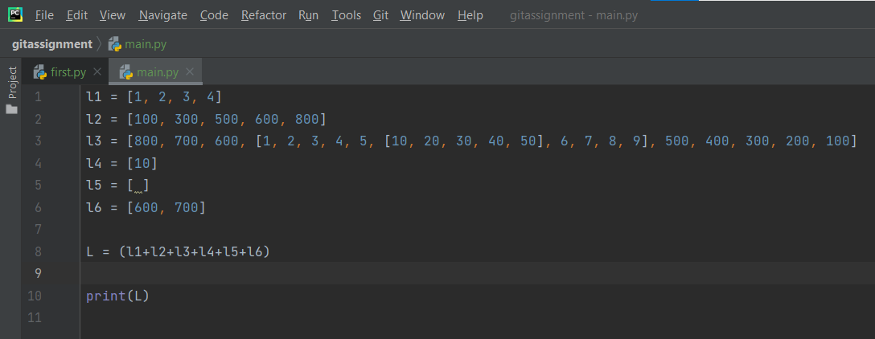

output



1. Create a list of thousand numbers using range and xrange and see the difference between each other.

Ans. Range return list of objects while Xrange returns integer objects.

Xrange return only one item at a time while range return a all items at once.

Xrange is faster than the range.

1. How Tuple is beneficial as compared to the list?

Ans.

* Tuple are immutable, iterating through tuple is faster than list.
* Tuple require less memory compared to list.

1. Write a program in Python to iterate through the list of numbers in the range of 1,100 and print the number which is divisible by 3 and is a multiple of 2.

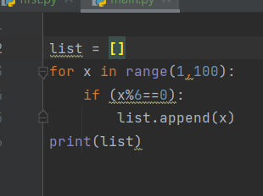

Output: 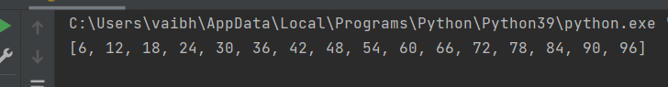

1. Write a program in Python to reverse a string and print only the vowel alphabet if it exists in the string with their index.

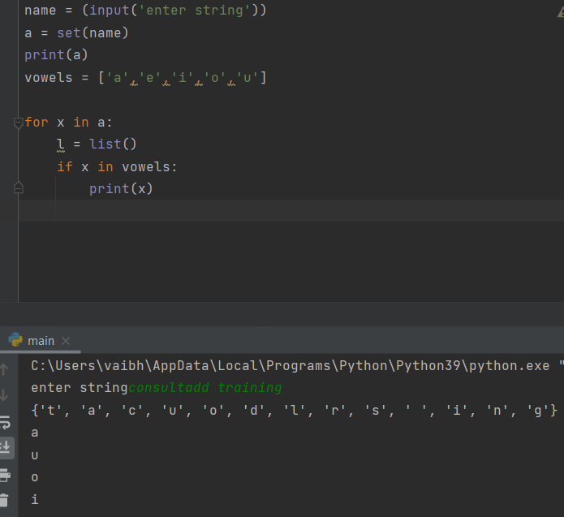

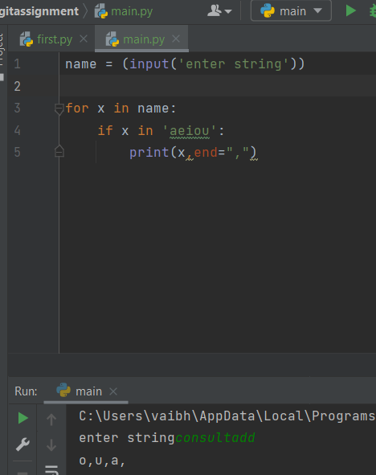

1. Write a program in Python to iterate through the string “hello my name is abcde” and print the string which is having an even length.

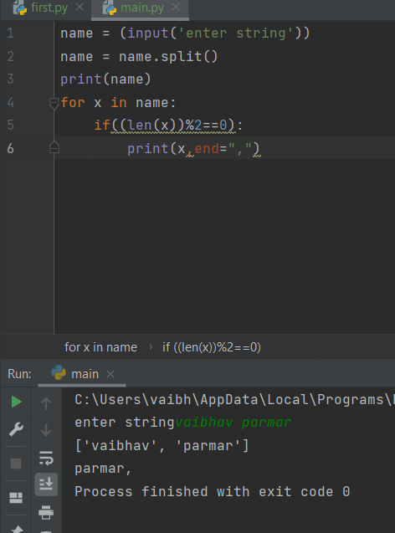

1. Write a program in python to print the pair of numbers whose sum is equal to the result number that is let's say 8.

x=[1,2,3,4,5,6,7,8,9,-1]

input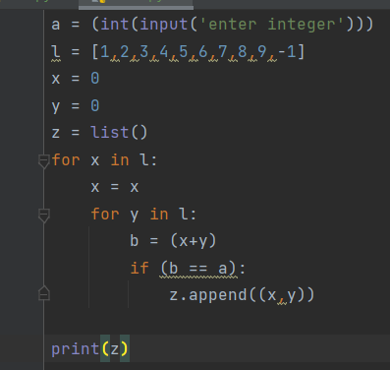

output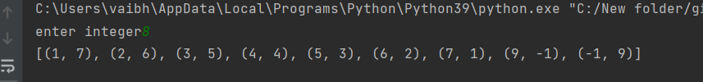

1. Write a program in python to complete the following task.

* Create two lists such as even list and odd list
* Ask user to enter a number in the range of 1,50 and make sure if the entered number is
* even, append it to the even list and if the entered number is odd append it to the odd list.
* Keep that in mind you can only add 5 items in each list
* Make sure once you enter all the 5 elements, calculate the sum of the list and return the
* maximum of the list.

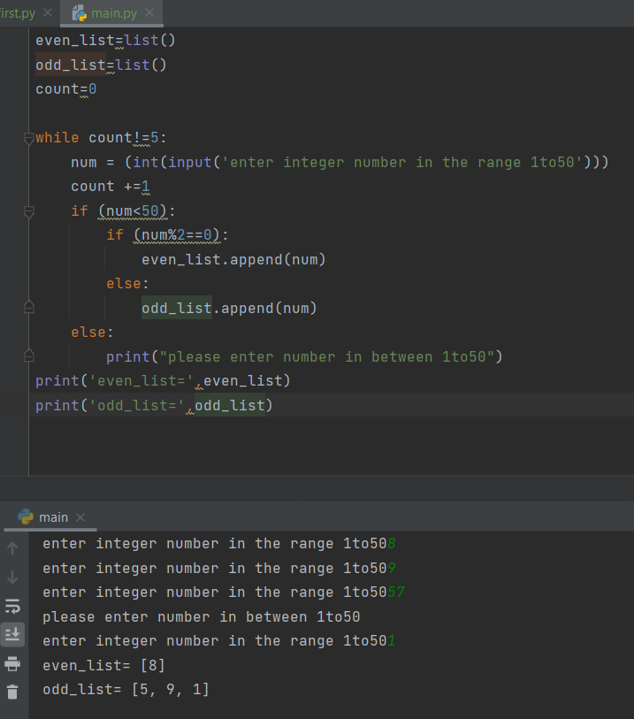

1. Write a program to find out the occurrence of a specific character from an alphanumeric string.

Sample input: 12abcbacbaba344ab

Expected output: a=5 b=5 c=2

input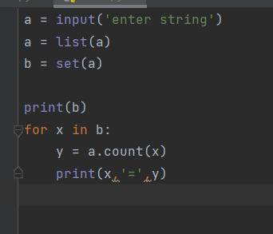

output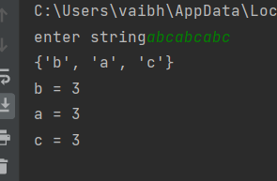

1. Generate and print another tuple whose values are even numbers in the given tuple

(1,2,3,4,5,6,7,8,9,10).

